## Dr. Mohammad Aalai MD Launches Innovative Pain Clinic Pain Free Lives, Expanding Non-Surgical Solutions for New Yorkers

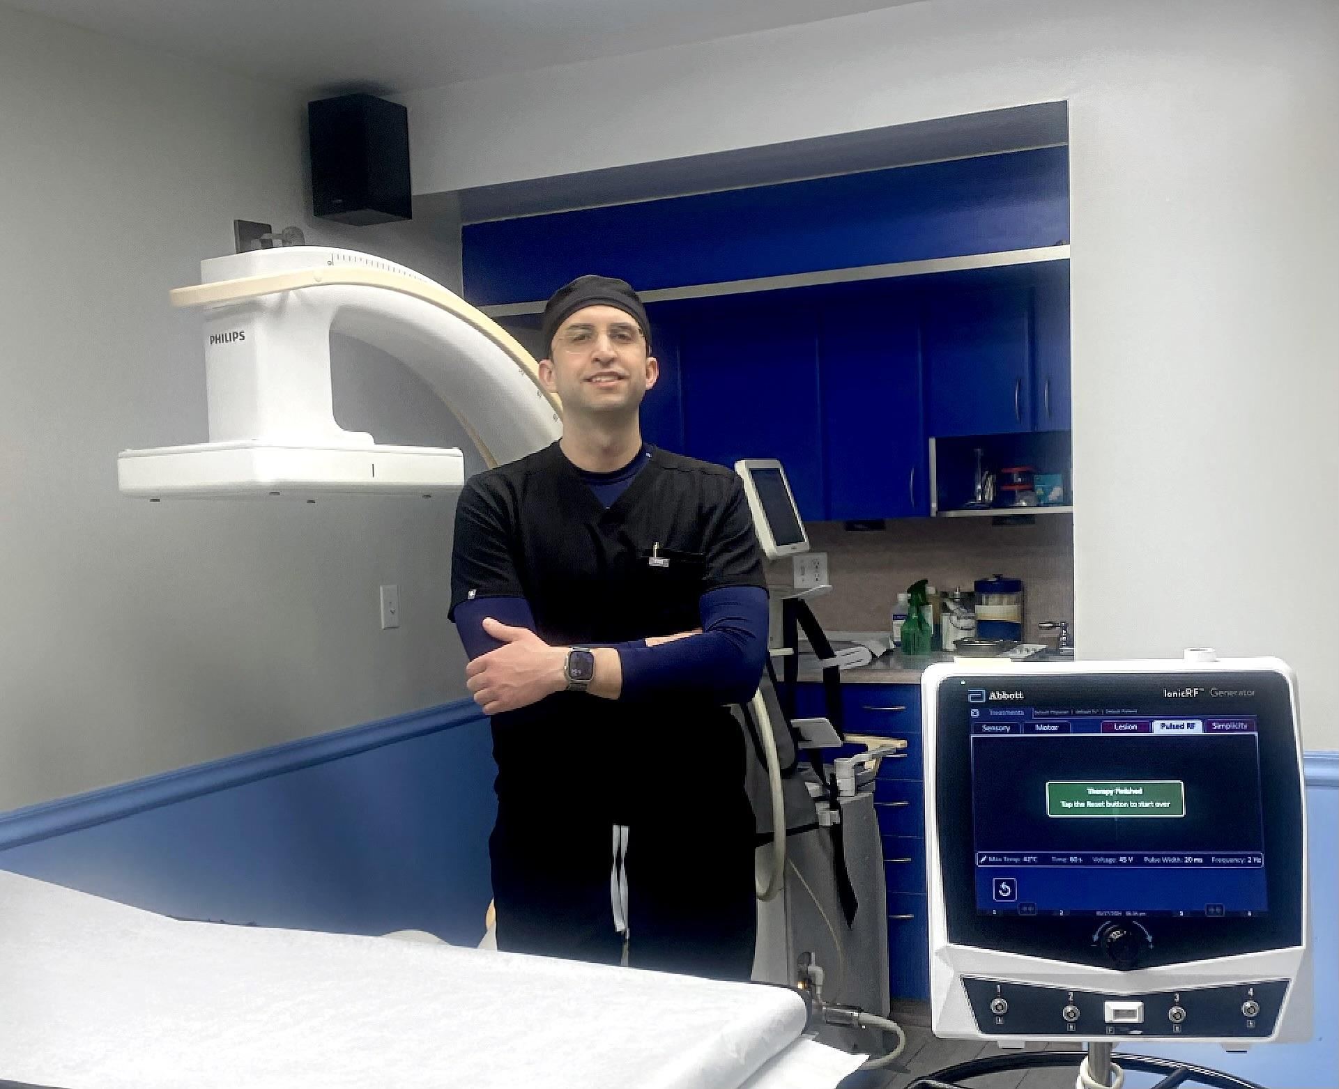

**New York, NY** – Chronic pain is a significant issue across the United States, affecting an estimated 50 million people. In New York City, the fast-paced, high-stress environment compounds the challenges faced by those living with daily pain.

Dr. Mohammad Aalai, MD, Program Director at the Physical Medicine and Rehabilitation Program at One Brooklyn Health, has launched Pain Free Lives, recognizing the critical need for effective pain management solutions, has recently opened a specialized clinic in Brooklyn, signaling the beginning of a broader initiative to address this pervasive health issue citywide.

The prevalence of chronic pain in urban settings like New York is not just a health problem but a social one, impacting economic stability and quality of life. Pain Free Lives, the initiative led by Dr. Aalai, aims to introduce advanced, non-surgical treatment options tailored to urban residents' unique needs. This initiative reflects a significant shift towards healthcare solutions encompassing holistic and regenerative therapies, which are crucial in a city where traditional pain management methods have often fallen short.

Dr. Aalai's approach centers on two pioneering treatments: Platelet-Rich Plasma (PRP) therapy and Bone Marrow Stem Cell therapy. Both treatments utilize the body’s biological mechanisms to treat pain at its source, offering alternatives to the often debilitating side effects of surgery and long-term pharmaceutical use. PRP therapy harnesses the healing properties of a patient’s blood platelets to accelerate recovery, while bone marrow stem cell therapy uses harvested cells to assist with pain reduction and improvement of daily function.

These methods are part of a broader movement in medicine that seeks to reduce dependency on opioids—a particularly urgent concern in New York City, where opioid abuse rates have escalated alongside chronic pain cases. With a focus on regenerative medicine, Dr. Aalai's clinics not only address pain but also work to mitigate the opioid crisis at a community level.

Understanding that effective treatment extends beyond the physical aspects of pain, Pain Free Lives emphasizes patient education and the development of personalized care plans. Dr. Aalai believes empowering patients through knowledge and tailored treatment strategies is essential for long-term health outcomes. Each clinic is staffed with specialists trained to guide patients through their treatment options, ensuring that each individual’s care is proactive and informed.

Accessibility is another cornerstone of Dr. Aalai’s mission. In the coming months, Pain Free Lives plans to extend its reach to all five boroughs but begins its journey in Brooklyn. This expansion aims to make non-surgical pain management solutions accessible to more people across Greater New York City. With each new clinic, Pain Free Lives offers patients more personalized, minimally invasive options to help them regain mobility and quality of life.

“Our goal is to ensure that every New Yorker, regardless of their background or economic situation, has access to effective, non-surgical treatments for pain,” reflected Dr. Aalai. “We are dedicated to providing solutions that are both innovative and accessible to all.”

The expansion of Pain Free Lives under Dr. Aalai’s guidance is set to reshape how chronic pain is treated in urban environments.

As Pain Free Lives grows, Dr. Aalai remains committed to a patient-centered approach, prioritizing long-term wellness over temporary fixes. The practice’s model, which combines medical innovation with a strong focus on community and education, offers a blueprint for other cities grappling with similar issues.

Through his efforts, Dr. Aalai is providing relief to thousands of New Yorkers and contributing to a more extensive dialogue about the future of healthcare in America’s cities. Pain Free Lives stands as a testament to the potential of innovative, compassionate healthcare to transform lives.

For more information, visit [- www.PainFreeLives.com](https://painfreelives.com/).

Media Contact:

Nadya Rousseau

[nadya@alternewmedia.com](mailto:nadya@alternewmedia.com)

310-853-3798